WELCOME to IACT’s Grants and Reports System

Access at http://cjp.spectrumportal.net/Accounts/Register
Log in with your email and the password.

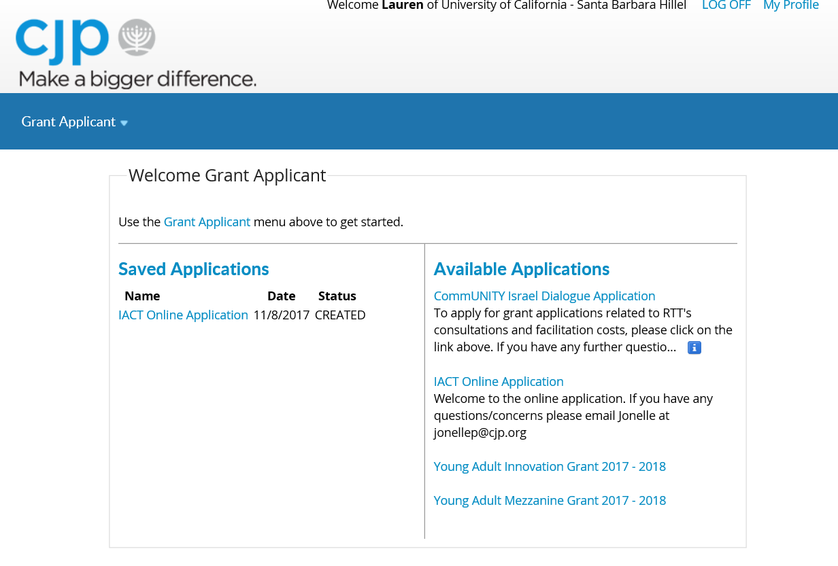
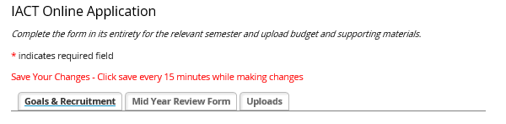
There are three tabs, review each tab and complete the information that is requested at this time.
- Goals & Recruitment is a table that measures your outcomes over the entire year.
- Mid-Year is to be completed with you Fall Semester progress in Nov/Dec. prior to you winter trip departure. Yearend Reports are due May/Jun for Summer Trip.
- Uploads hold your budget, presentations, media samples, etc.
SAVE OFTEN.
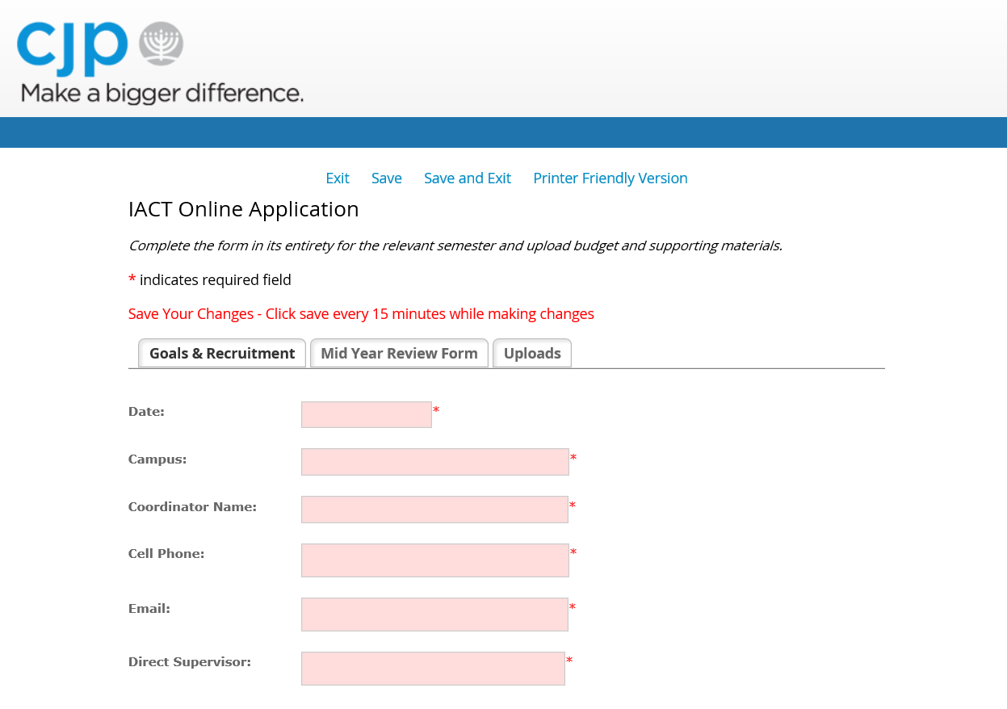
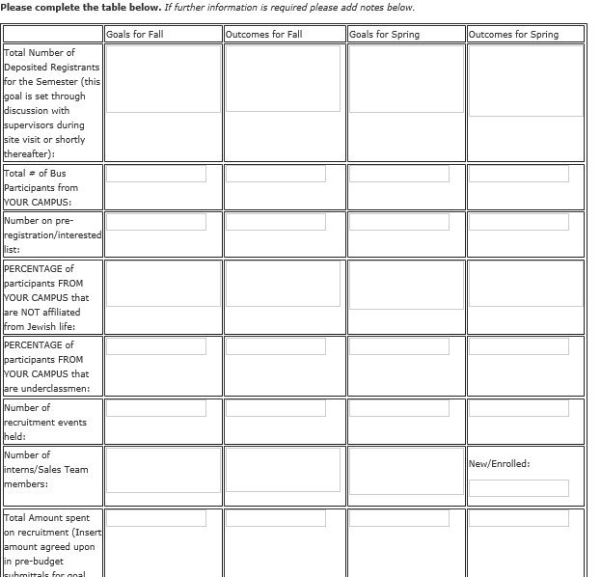
If goals are not filled in, please take a moment and complete the table. You will revisit this table throughout the year to measure your outcomes against your goals.
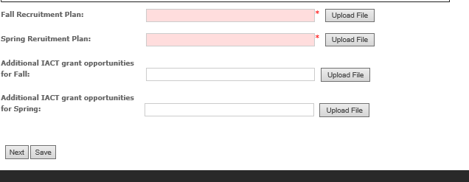
At the bottom of the Goals & Recruitment Tab you will be asked to upload your Recruitment Plans and your Additional Grant Opportunities.
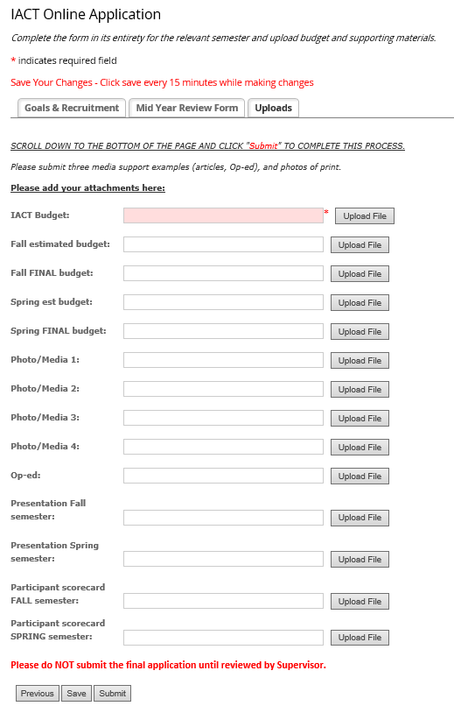
Mid-Year and Year End Reports are the same questions from previous years. You will complete the questions online this year.

Uploads is a tab for all other materials.
Here you will be asked to include:
- Budgets projected and actuals at the end of the semesters
- Presentations in PowerPoint format
- Photos or Media samples
- Participant Scorecards in excel format
Please do not hit submit till you have reviewed all information with supervisor. Once the report is submitted it is final.

